EXPERIMENT NO:22

Design PDA using simulator to accept the input string aabb

AIM: To Design PDA using simulator to accept the input string aabb

INPUT:

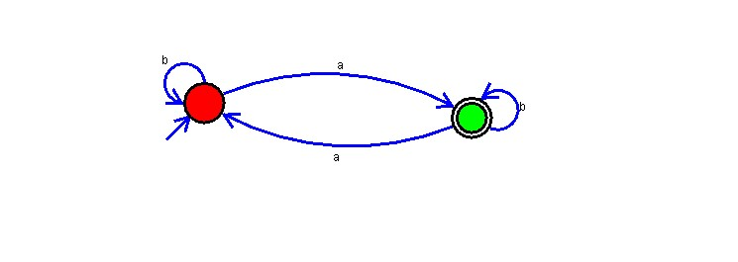

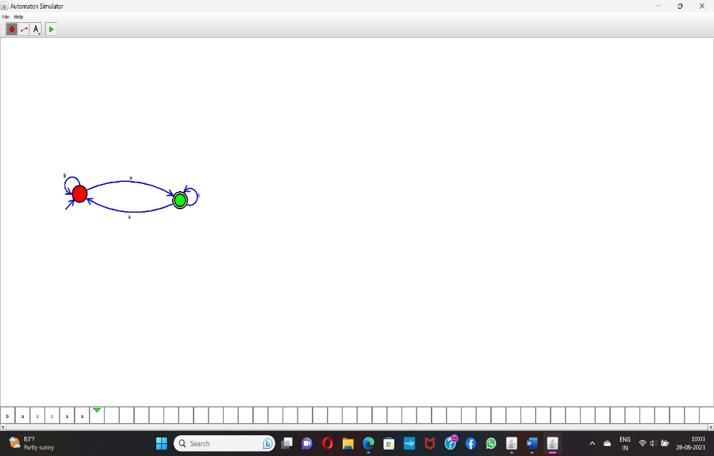OUTPUT:

RESULT: The program got executed successfully and got output.